Using this hack you can [register](javascript:void(0);) [the Internet](javascript:void(0);)Download Manager (IDM) for free using you own credentials i.e register on your Name and email ID for free.

Using this hack you can register the Internet Download Manager (IDM) for free using you own credentials i.e register on your Name and email ID

Hack or [crack](javascript:void(0);) IDM manually :

Step 1: Download the IDM trial or If you already have IDM installed

Update it by going to Help---}} then to check for Updates.If you don't wanna update your version, Just click on [Registration](javascript:void(0);).

Step2: When you click on registration, Now a new dialog(window) appears that is asking for Name, Last Name, Email Address and Serial Key.

Step3: Now Enter you name, last name, email address and in field of Serial Key enter any of the following Keys:

RLDGN-OV9WU-5W589-6VZH1

HUDWE-UO689-6D27B-YM28M

UK3DV-E0MNW-MLQYX-GENA1

398ND-QNAGY-CMMZU-ZPI39

GZLJY-X50S3-0S20D-NFRF9

W3J5U-8U66N-D0B9M-54SLM

EC0Q6-QN7UH-5S3JB-YZMEK

UVQW0-X54FE-QW35Q-SNZF5

FJJTJ-J0FLF-QCVBK-A287M

 And click on ok to register.

Step4: After you click ok, it will show an error message that you have registered IDM using fake serial key and IDM will exit. Now here the hack starts.

Step5: Now Go to START => Then go to RUN and type the following text and click enter:

notepad %windir%system32driversetchosts

Note : For Windows 7 users, due to security reasons you will not be able to save hosts file.

so follow this steps :

First of all go to C:/ drive then go to Windows Folder and then go to System32 folder and then go to Drivers folder and then go to Etc Folder, in the Etc folder you will see the hosts file.

Step6: Now right click on hosts file and go to its properties, then go to security tab and then select your admin account, just below u will see an edit button (in front of change permissions), Now give the user full control and write and read rights and then click on apply and then click on Ok, now u will be able to edit the hosts file and save changes in it.

Note : if you are login through admin then skip this step6 .Its just for granting permission for editing file.

Step7: Now a notepad file appears something like this as shown below

Now copy the below lines of code and add to hosts file as shown above image box :

[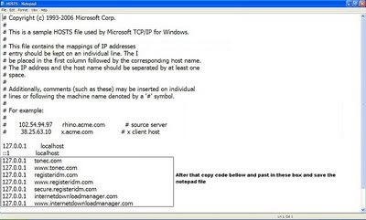](http://2.bp.blogspot.com/-6V5amNV5EDk/Th7Yq2vzl8I/AAAAAAAAAOs/8wtwyt6cqnY/s1600/Hack-IDM-Manually.JPG)

127.0.0.1 tonec.com

127.0.0.1 www.tonec.com

127.0.0.1 registeridm.com

127.0.0.1 www.registeridm.com

127.0.0.1 secure.registeridm.com

127.0.0.1 internetdownloadmanager.com

127.0.0.1 www.internetdownloadmanager.com

127.0.0.1 secure.internetdownloadmanager.com

127.0.0.1 mirror.internetdownloadmanager.com

127.0.0.1 mirror2.internetdownloadmanager.com

After adding these piece of code, save the notepad file. And exit from there.

Now start your Internet download manager, and now you IDM has been converted to full version.

That means it will remain full version for life time and you can update it without any problem in future.

[proof](javascript:void(0);) of Successfully Hacking IDM:

[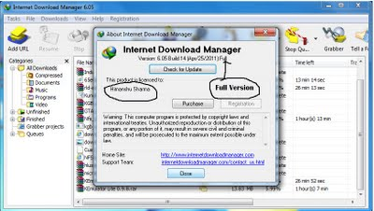](http://2.bp.blogspot.com/-JKh7cF4mFVo/Th7Y1dUX8AI/AAAAAAAAAOw/FJmGOCSQSe8/s1600/idm+proof.jpg)